Software Requirements Specification

For

DREAM BRICKS

version 1.0

Table of Contents

Table of Contents ii

Revision History ii

1. Introduction 3

1.1 Purpose 3

1.2 Document Conventions 3

1.3 Intended Audience and Reading Suggestions 3

1.4 Product Scope 3

1.5 References 3

1.6 Technology Used………………………………………………………....….4

2. Overall Description 4

2.1 Product Perspective 4

2.2 Product Functions 4

2.3 User Classes and Characteristics 5

2.4 Operating Environment 6

2.5 Design and Implementation Constraints 6

2.6 Assumptions and Dependencies 6

3. External Interface Requirements 6

3.1 User Interfaces 6

3.2 Hardware Interfaces 6

3.3 Software Interfaces 6

3.4 Communications Interfaces 7

4. System Features 7

4.1 System Feature 1 7

5. Other Nonfunctional Requirements 8

5.1 Performance Requirements 8

5.2 Safety Requirements 9

5.3 Security Requirements 10

5.4 Software Quality Attributes 10

# Introduction

## Purpose

The purpose of this application is to build an online system that serves as the barrier in the field of real estate among the people involved in buying, selling activities.

## Document Conventions

This document uses the following conversions.

|  |  |
| --- | --- |
| **DATABASE** | DB |
| **SOFTWARE ENGINEERING** | SE |

## Intended Audience and Reading Suggestions

This project is a prototype for the real-estate management system and it is an academic project for Software Package Development Lab. This project is useful for the buyers as well as the sellers. This project is based on the contents of the courses SE and DBMS. From DBMS course, sections on ER model, data dictionary and tables are developed.

## Product Scope

Real estate management application main focus is to enrich the relationship between the buyer and the seller of the property. It eases the communication between the people enabling them a safer search results and properties are checked for legitimateness before they are posted on the walls. Its main aim is to create and ensure a safer platform.

## References

* **IEEE SRS Format**
* SE by….
* Fundamentals of database systems by Ramezelmarsi and shamkantb. Navathe

## Technologies to be used

* Database Application: MySQL
* Designing tool: Adobe Xd, Adobe Illustrator
* Web Server: Apache

# Overall Description

## Product Perspective

A Web based real estate management system is to be developed. The actors using it will be the user, admin and the review team.

It must contain the following features

1)**User Details:**

It contains all the necessary information such name, age and the type of user to authenticate the user’s login inside the system.

2)**Property Details:**

It contains all the necessary information such As the type of property, area in which it is situated and price the seller is expecting and all the legitimate information regarding the property.

## Product Functions

### usecaseUSER CASE MODEL

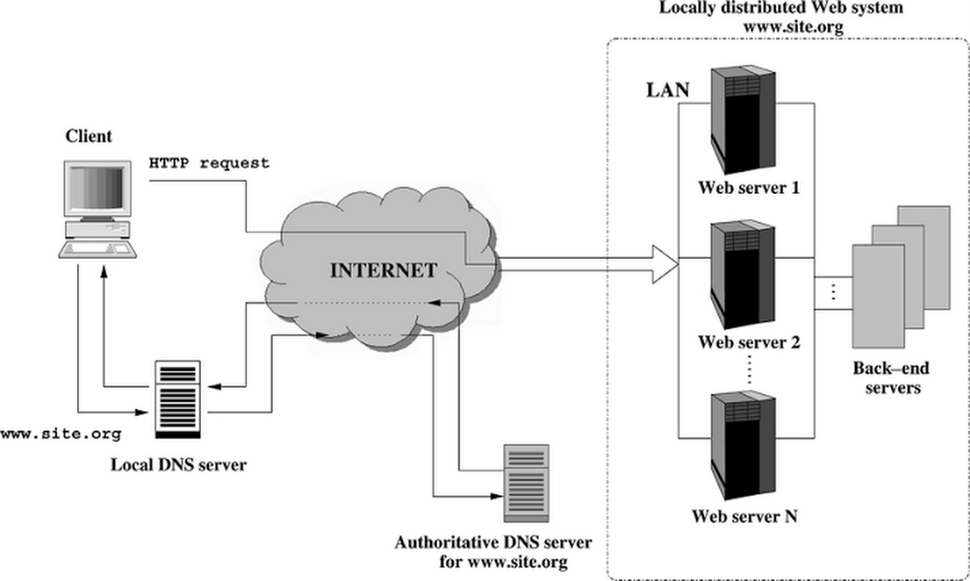**2.2.2 Web Architecture Diagram**

## User Classes and Characteristic

The system will support two types of user privileges, Customer, and Employee. Customers will have access to customer functions such as post an ad or to view an ad, and the employees will have access to both customer and application management functions. The customer should be able to do the following functions:

* Post/view an advertisement
* Review and ratings can be submitted
* Contact information can be asked
* Update their information

The Employee should have following management functionalities:

EMPLOYEE FUNCTIONS:

* Maintaining the review team
* Maintaining the database
* Maintain the payment details for the subscriptions

## Operating Environment

The application for a real estate management application this will be the operating environments.

1. Distributed Database
2. Client/server system
3. Operating system: windows/Mac
4. Database: MySQL database
5. Platform: PHP

## Design and Implementation Constraints

There are a few constraints for the implementation of the application. They are

1. the information of the user is not given directly, the user himself will decide whether to give access to his data.
2. The application is designed in such a way that your ad undergoes a two-stage verification before posting.

## Assumptions and Dependencies

1. The database system is assumed to be distributed.
2. The user is assumed to have access to internet and has a knowledge on terms and conditions provided

# External Interface Requirements

## User Interfaces

* Front-end software: Html, CSS
* Back-end software: MySQL

## Hardware Interfaces

* Windows
* Browser which supports CGI, HTML &JavaScript.

## Software Interfaces

Following are the software used for the DREAM BRICKS

|  |  |
| --- | --- |
| SOFTWARES USED | DISCRIPTIOIN |
| Operating systems | We have used window operating system version 10 for its best performance and its  User-friendliness |
| Database | To store the data of the buyers, sellers and the information of the property |

## Communications Interfaces

This project supports all types of web browsers. We are using simple electronic forms to get the information about the buyers, sellers and the property.

# System Features

### Description and Priority

DREAM BRICKS maintain the information about the buyers and sellers and the complete info about the property. This project has a high priority as its very difficult to buy and sell a property as there are more complications in searching information about the property and security of it.

### Stimulus/Response Sequences

* Searching for property of specific requirements.
* Display the detailed list of property and book the property
* Cancelling the booked property.

### Functional Requirements

Other system features include:

**DISTRIBUTED DATABASE:**

Distributed database implies that a single application should be able to operate transparently on data that is spread across a variety of different databases and connected by a communication network as shown in below figure.



Distributed database located in main cities like Chennai, Coimbatore etc.,

**CLIENT/SERVER SYSTEM**

The term client/server refers primarily to an architecture or logical division of responsibilities, the client is the application (also known as the front-end), and the server is the DBMS (also known as the back-end). It consists of two parts,

* Client systems
* Server systems

They both communicate over a computer network or on the same computer.

# Other Nonfunctional Requirements

## Performance Requirements

The steps involved to perform the implementation of airline database are as listed below.

**E-R DIAGRAM**

The E-R Diagram constitutes a technique for representing the logical structure of a database in a pictorial manner. This analysis is then used to organize data as a relation, normalizing relation and finally obtaining a relation database.

* **ENTITIES:** Which specify distinct real-world items in an application.
* **PROPERTIES/ATTRIBUTES:** Which specify properties of an entity and relationships.
* **RELATIONSHIPS:** Which connect entities and represent meaningful dependencies between them.

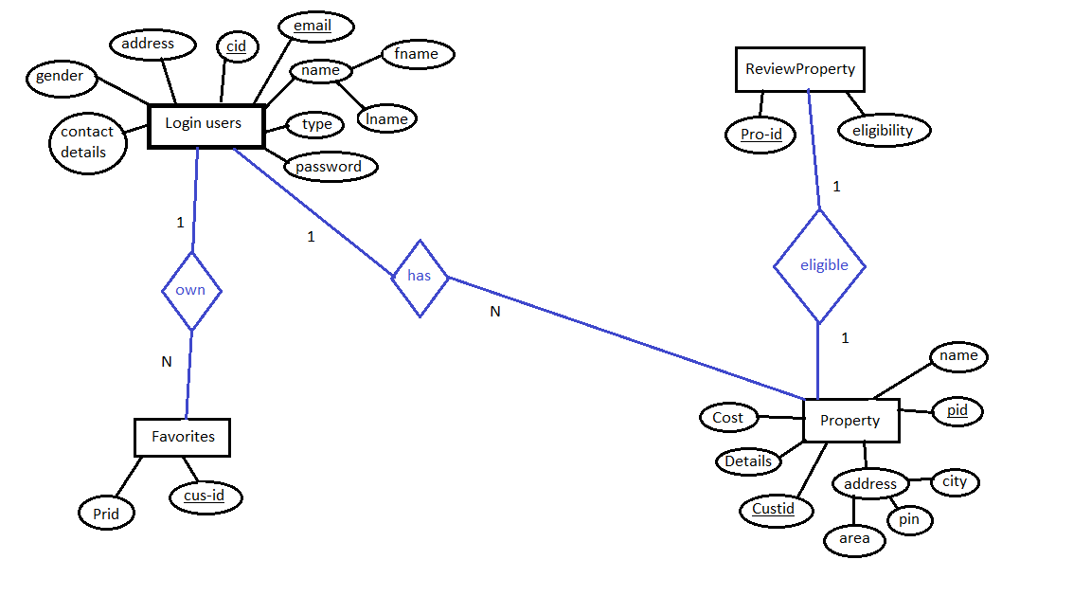

The diagram shows the ER diagram of real estate database.

## Safety Requirements

The system associated with payment should be at its best performance and fully secured. So, the pages linked with payments cannot be reloaded because it put the system at risk.

## Security Requirements

Security systems need database storage just like many other applications. However, the special requirements of the security market mean that vendors must choose their database partner carefully.

## Software Quality Attributes

* **AVAILABILITY:** The property that a buyer is searching for should be available
* **CORRECTNESS:** The search results should be relevant to the property that has been displayed
* **MAINTAINABILITY:** The seller should maintain the correct details of the property
* **USABILITY:** The properties should satisfy the need of number of users